[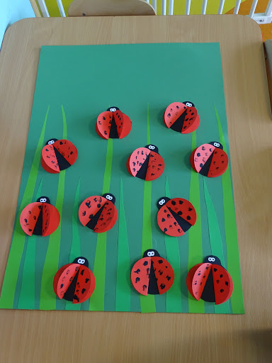](https://www.google.pl/url?sa=i&url=http://www.zlobekledziny.pl/praca-plastyczna-biedronki/&psig=AOvVaw2f20qpQtGmM_l3q6Cw7PhF&ust=1589990811246000&source=images&cd=vfe&ved=0CAIQjRxqFwoTCNjy18KnwOkCFQAAAAAdAAAAABAL)

[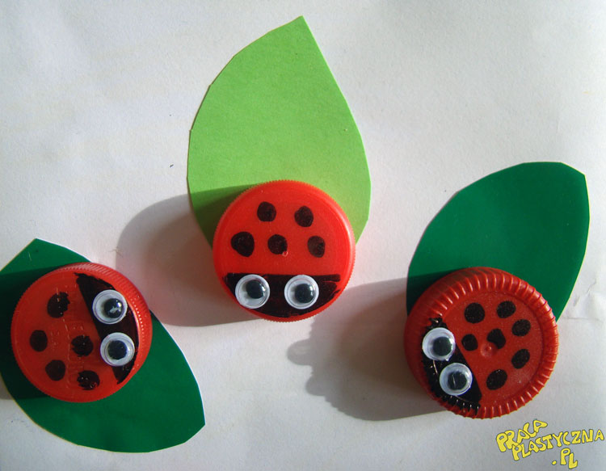](https://www.google.pl/url?sa=i&url=https://pracaplastyczna.pl/index.php/zwierzeta/1216-obudzone-biedronki&psig=AOvVaw2f20qpQtGmM_l3q6Cw7PhF&ust=1589990811246000&source=images&cd=vfe&ved=0CAIQjRxqFwoTCNjy18KnwOkCFQAAAAAdAAAAABAR)

[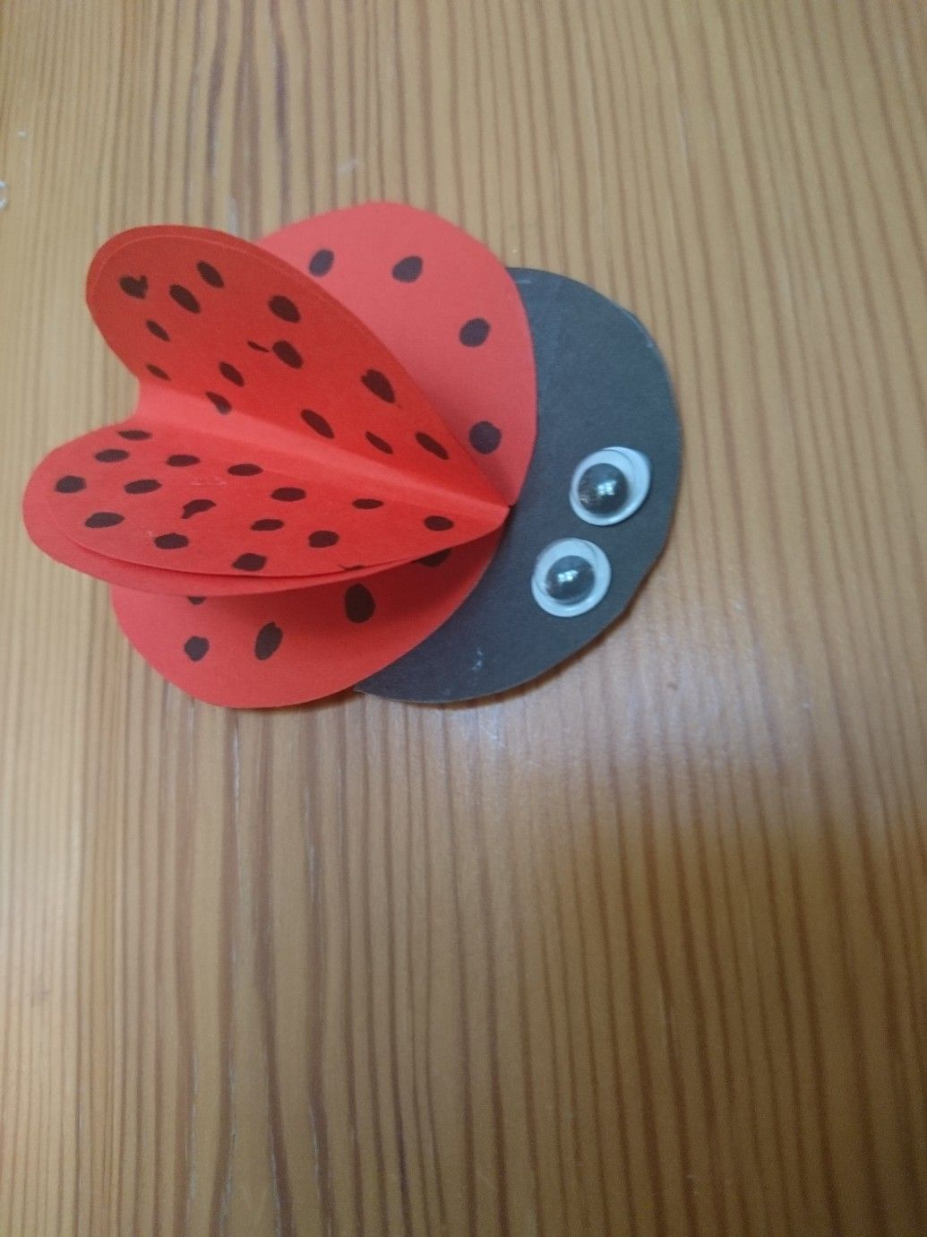](https://www.google.pl/url?sa=i&url=https://pl.pinterest.com/pin/266275396702084957/&psig=AOvVaw2f20qpQtGmM_l3q6Cw7PhF&ust=1589990811246000&source=images&cd=vfe&ved=0CAIQjRxqFwoTCNjy18KnwOkCFQAAAAAdAAAAABAW)

[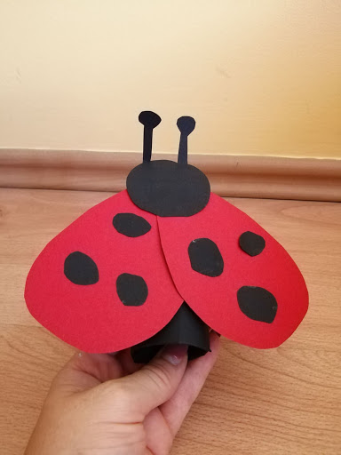](https://www.google.pl/url?sa=i&url=http://edufunkids.com/biedronka-praca-plastyczna-z-wykorzystaniem-rolki/&psig=AOvVaw2f20qpQtGmM_l3q6Cw7PhF&ust=1589990811246000&source=images&cd=vfe&ved=0CAIQjRxqFwoTCNjy18KnwOkCFQAAAAAdAAAAABAb)

[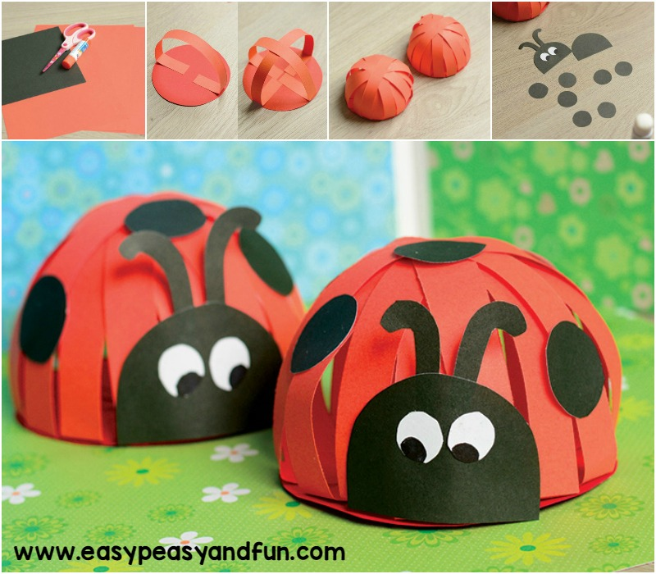](https://www.google.pl/url?sa=i&url=http://www.kiedymamaniespi.pl/2017/03/30-pomyslow-na-wiosenne-zabawy-plastyczne-dla-dzieci.html&psig=AOvVaw2f20qpQtGmM_l3q6Cw7PhF&ust=1589990811246000&source=images&cd=vfe&ved=0CAIQjRxqFwoTCNjy18KnwOkCFQAAAAAdAAAAABAh)

[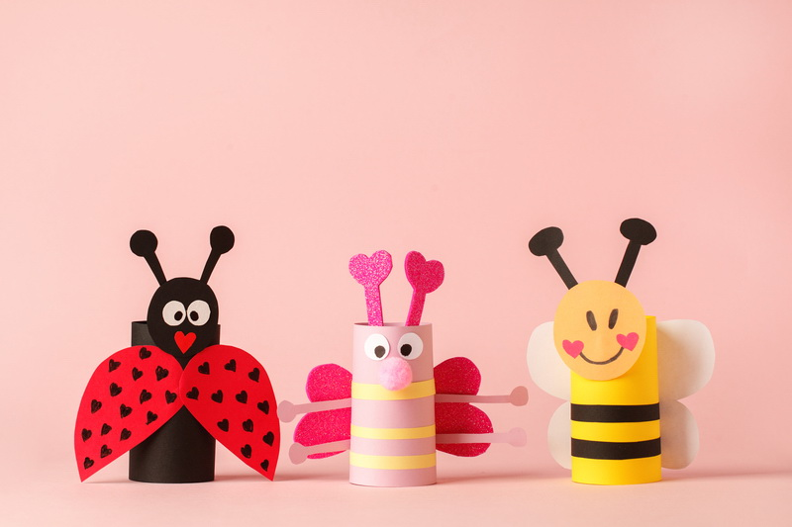](https://www.google.pl/url?sa=i&url=https://miastodzieci.pl/zabawy/wiosenny-wianek/&psig=AOvVaw2f20qpQtGmM_l3q6Cw7PhF&ust=1589990811246000&source=images&cd=vfe&ved=0CAIQjRxqFwoTCNjy18KnwOkCFQAAAAAdAAAAABAn)